The eclectic nature of Jeremiah David Tindall’s music reflects the wide array of experiences that culminate in his present compositions. His unique style is a blend of reggae, folk, and classical sounds, which are woven strands from the various elements of his musical background.

With an undergrad in Music from Knox College and a graduate degree in Music Business from the University of Miami, Jeremiah has formal training on violin, guitar, and piano along with first-hand experiences learning cultural music styles in Kingston, Jamaica and Mali, West Africa. Followed by seasons of work aboard tall ships, at summer camps, on organic farms, and inside a variety of blue-collar industries, his lyrical content incorporates the perspective of the working man and the adventurer. Resourceful and contemplative, his compositions merge cultures and styles that parallel his travels.

Jeremiah currently resides in Miami, FL and serves as the Site Director of Liberty City chapter for the Miami Music Project, a non-profit bringing orchestral opportunities to students in under-resourced communities throughout Miami-Dade County. He has worked in a variety of settings with youth including camp counseling, teaching, and after school programs.

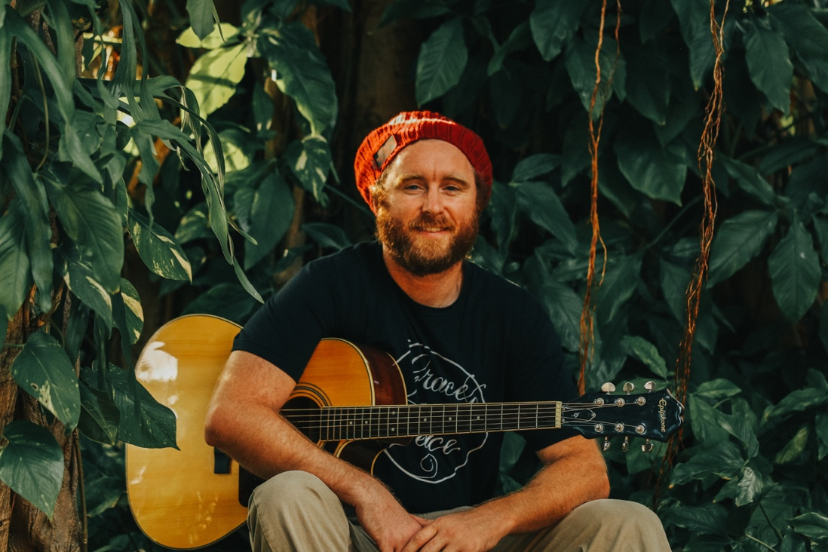

Collaborating with Teaching Artists from the Miami Music Project and fellow musicians from his local congregation, Miami Bible Church, Jeremiah now seeks to advance the truth and light of the Scriptures to his audience through the joy of music as he brings years of experience and longstanding musical efforts to the table. While he serves the community of Liberty City and encourages children in their musical development, he writes and arranges original acoustic reggae music combined with a variety of classical chamber ensemble accompaniments. The sound is a natural outflow of the adventurous life he has lived and an expression of the Christian faith he holds dear.

