Jeremiah David Tindall

"As a pastor, I know that music has come down from heaven above as God's good gift to mankind to lift up a person's mind & soul back toward the heavenlies. So the best thing I can say about Jeremiah's musical skills - vocal, instrumental, and compositional - is that they are uplifting."

David Diez – Pastor – Miami Bible Church

"Jeremiah is a very talented musician who is continuously willing to learn and work hard. What I appreciate most is that he dedicates his talent and musicianship to the Glory of God."

Greg Xiques – Music Minister – Miami Bible Church

Musician
Educator
Entrepreneur
Songwriter
Arranger

www.jeremiahdavidtindall.com Twitter: @TindallJeremiah
www.facebook.com/jeremiahdavidtindall/ Instagram: @jeremiahdavidtindall

Jeremiah David Tindall - Bio
www.jeremiahdavidtindall.com

The eclectic nature of Jeremiah David Tindall’s music reflects the wide array of experiences that culminate in his present compositions. His unique style is a blend of reggae, folk, and classical sounds, which are woven strands from the various elements of his musical background.

With an undergrad in Music from Knox College and a graduate degree in Music Business from the University of Miami, Jeremiah has formal training on violin, guitar, and piano along with first-hand experiences learning cultural music styles in Kingston, Jamaica and Mali, West Africa. Followed by seasons of work aboard tall ships, at summer camps, on organic farms, and inside a variety of blue-collar industries, his lyrical content incorporates the perspective of the working man and the adventurer. Resourceful and contemplative, his compositions merge cultures and styles that parallel his travels.

Jeremiah currently resides in Miami, FL and serves as the Site Director of Liberty City chapter for the Miami Music Project, a non-profit bringing orchestral opportunities to students in under-resourced communities throughout Miami-Dade County. He has worked in a variety of settings with youth including camp counseling, teaching, and after school programs.

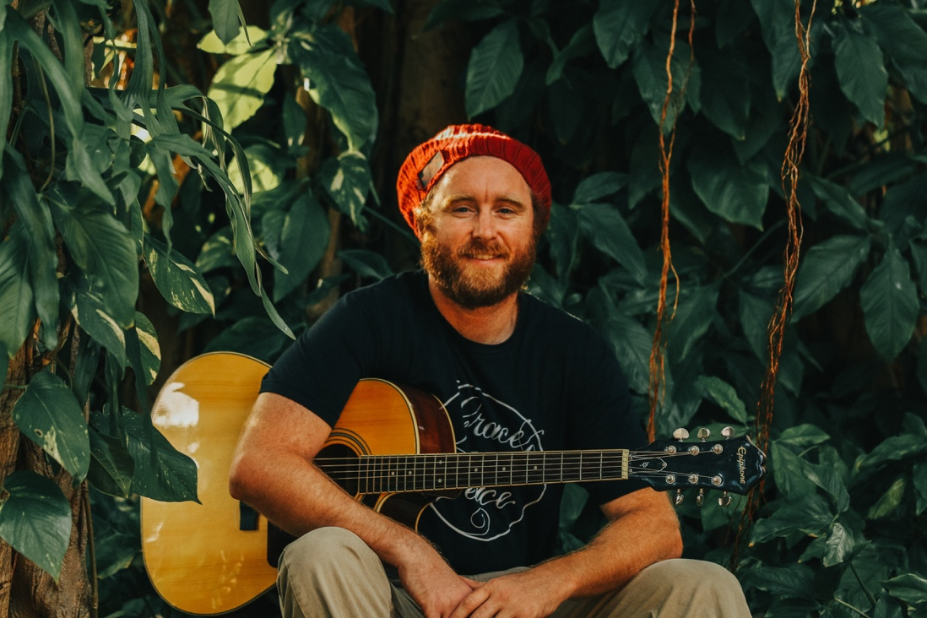

Collaborating with Teaching Artists from the Miami Music Project and fellow musicians from his local congregation, Miami Bible Church, Jeremiah now seeks to advance the truth and light of the Scriptures to his audience through the joy of music as he brings years of experience and longstanding musical efforts to the table. While he serves the community of Liberty City and encourages children in their musical development, he writes and arranges original acoustic reggae music combined with a variety of classical chamber ensemble accompaniments. The sound is a natural outflow of the adventurous life he has lived and an expression of the Christian faith he holds dear.

For Booking/Publicity/Other Inquiries, please contact:
info@jeremiahdavidtindall.com
786.955.3303
289 Ne 80th Terrace, Miami, FL 33138
Projects and Ensembles

Jeremiah David Tindall and Company:
www.jeremiahdavidtindall.com

Jeremiah writes and arranges original reggae compositions for acoustic performance with chamber ensembles and performs at various locations through Miami-Dade County. He performs alongside various UM and FIU music graduates. Previous venues include the Little Haiti Cultural Center and the First Baptist Church of Hialeah. Seeking new venue opportunities, stay tuned for new locations to catch his original and dynamic performances.

Miami Music Project:
www.miamimusicproject.org

The Miami Music Project is a 501c3 non-profit organization that works to bring social transformation in various communities throughout Miami-Dade County by way of its after school and summer camp orchestra programs as it works in partnership with the Miami-Dade County Public Schools. Jeremiah is currently the administrative Site Director of the Liberty City chapter where he oversees around 80 students and 15 Teaching Artists in their weekly activities. Chapter students perform several times throughout the school year and learn a variety of wind and brass instruments.

Miami Bible Church:
www.miamibiblechurch.org

Jeremiah serves the music ministry team at Miami Bible Church on a monthly basis during their Sunday morning worship services. He serves alongside Music Minister, Greg Xiques and family, and regularly rehearses with musicians from Miami Bible Church for the edification and upliftment of the church.

Press Photos
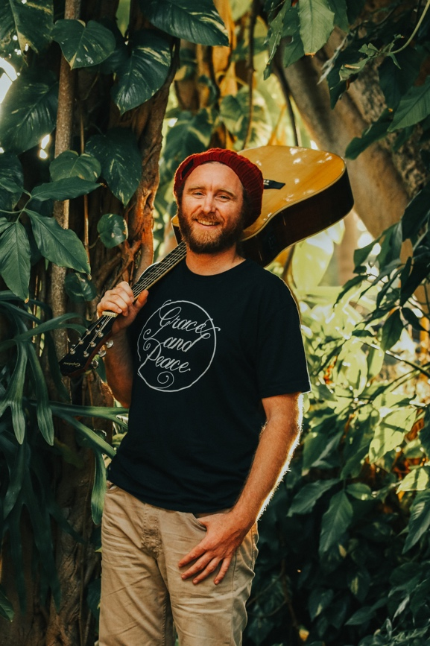
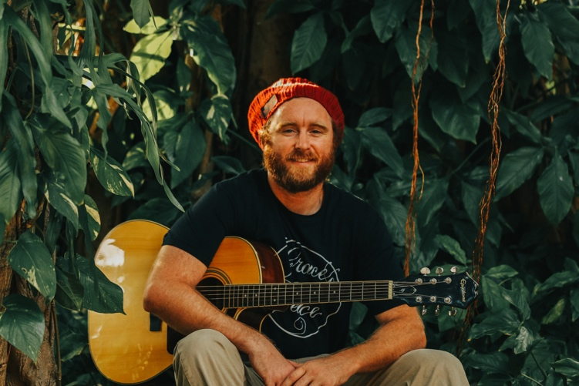

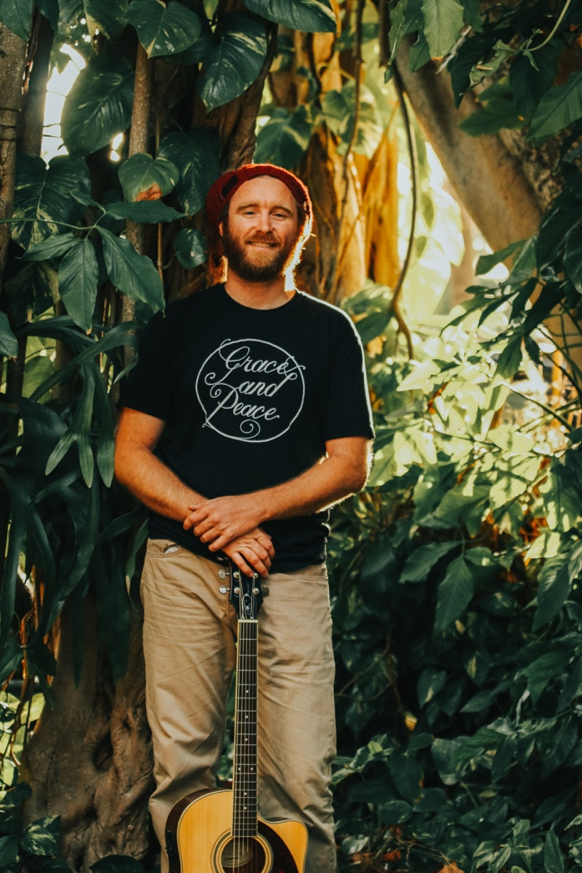

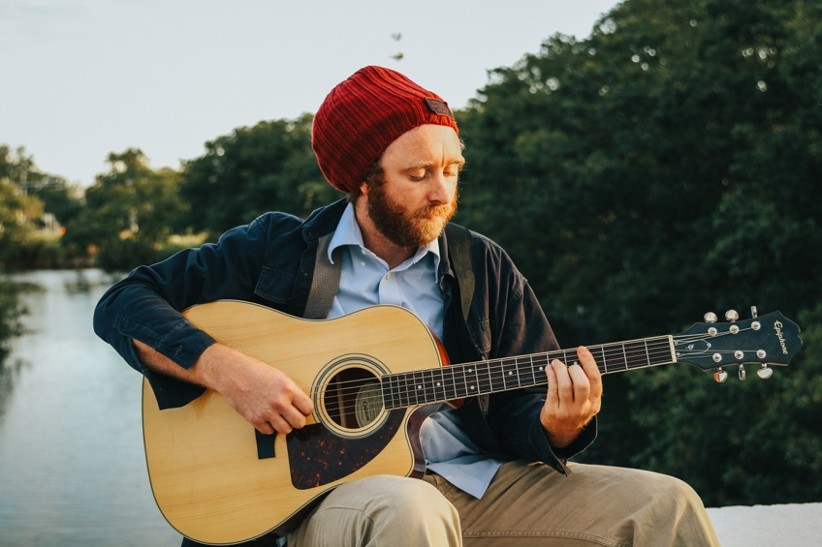

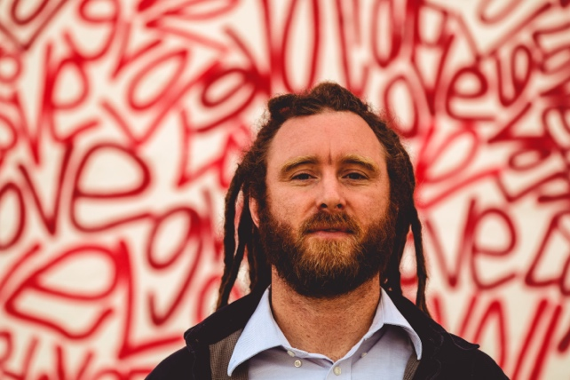

Press Clippings
