Jeremiah David Tindall Artist Bio (Long)

The eclectic nature of Jeremiah David Tindall’s music reflects the wide array of experiences that culminate in his present compositions. His unique style is a blend of reggae, folk, and classical sounds, which are woven strands from the various elements of his musical background.

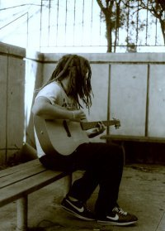
Raised in the Midwest, Jeremiah began studying the violin at age 10, and spent his middle and high school years performing in school orchestras and other community fine arts organizations. His mother was the pianist at their local church and his father, an aspiring folk/acoustic guitar player. At age 15, he received his first guitar, and, after writing his first song, his pursuit of songwriting and performing was concrete from the very beginning.

After high school, Jeremiah obtained a bachelor’s degree in Music with a minor in Creative Writing from Knox College in Galesburg, Illinois. During his undergrad years, he took private lessons for two years on classical piano (Amber Clark) and classical guitar (Randy Pobanz) and two years on jazz piano (Kevin Hart) and jazz guitar (Andy Crawford) while studying music theory and history. His creative writing minor was comprised mainly of poetry courses under the direction of Nicholas Regiacorte (University of Iowa’s Writer’s Workshop) with the goal of improving his song lyric abilities.

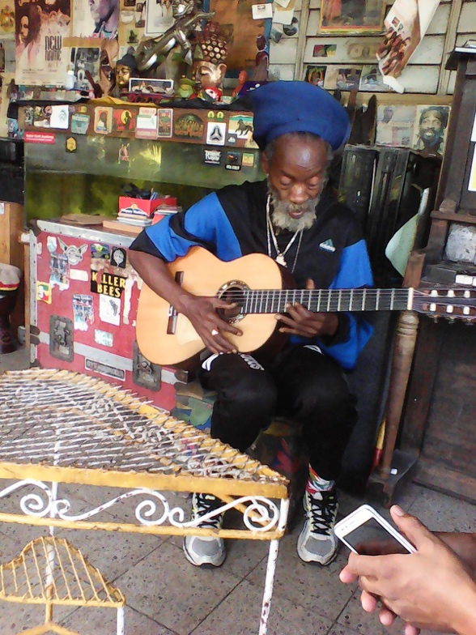
His undergrad years also opened the door for traveling abroad. His junior year included a semester of study at the Edna Manley College of Fine Arts in Kingston, Jamaica. While there, he studied reggae piano under Ibo Cooper (Third World) and guitar with Jamaican jazz guitarist, Maurice Gordon, while taking various courses on Jamaican popular and folk music. He also stumbled across a chance opportunity to spend a significant amount of time under the tutelage of Earl “Chinna” Smith (Bob Marley and the Wailers, Burning Spear, Jimmy Cliff, Ziggy Marley) where he would collaborate with a number of local Jamaican artists at Smith’s house near Halfway Tree. These sessions included trips to local recording studios such as Tuff Gong Studios, and a guest appearance on recordings for the French project “Inna De Yard.
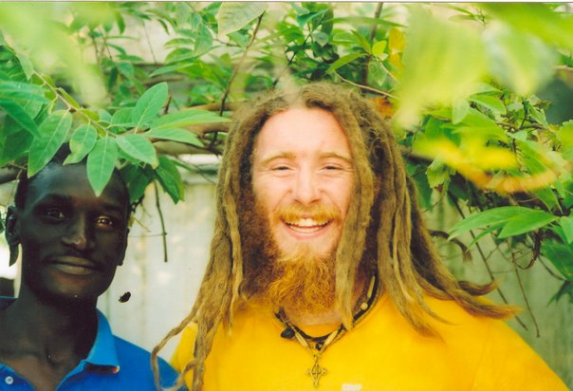
Following his initial trip to Jamaica, Jeremiah spent the first semester of his senior year at Knox traveling through the West African country of Mali studying West African percussion. After observing the national young arts competition in Bamako (the annual Biennale) he traveled through various regions including Mopti, Djenne, Timbuktu, and Dogon country before returning to Bamako and living with a local family for the remainder of his stay. After an unfortunate bout with malaria and other health complications, he returned to the United States, but the impact of West African music had made its mark.

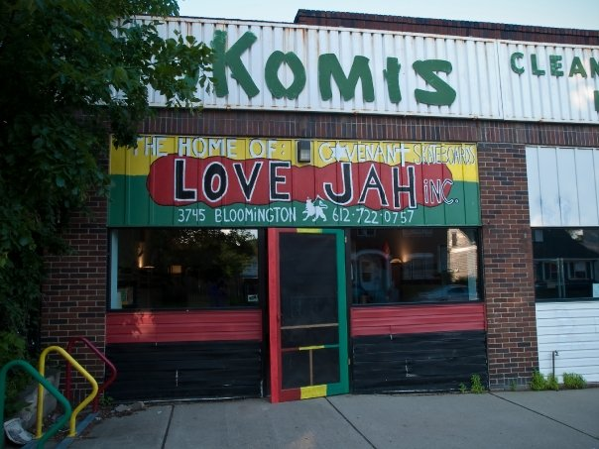
Upon graduation, Jeremiah soon moved up to Minneapolis, Minnesota to pursue a degree at the Institute of Production and Recording. Unable to gather the financial resources necessary to attend IPR and in need of employment, he soon began work for the Minneapolis Public School system as a substitute teacher and shortly after as an educational assistant. Along with his public school service, he also became the house manager for a residence serving adults struggling with mental illness, and opened up a small skateboard shop on the south side of the city. He studied guitar briefly with Congolese guitarist Siama Matuzungidi and jazz violin with Kale Olson Reed while in Minneapolis, but he struggled to find the needed time to pursue musical ends with the heavy workload.

However, as music was still his desired pursuit, he soon left the complexities of Minneapolis behind and returned to Jamaica in hopes of pursuing his dreams of performing. Upon arrival, he was able to work together with Chinna and other musical artists such as Leroy “Horsemouth” Wallace on several original tracks, but his limited experience in “the business” proved these efforts unprofitable towards launching an artist career. These studio sessions proved vital, however, in learning the ins and outs of the recording process even though they did not produce finished material for release.

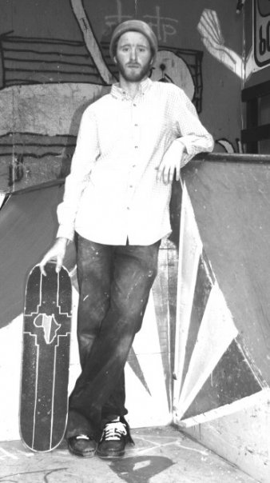
After several months, in order to comply with immigration policy, he returned to the United States to work aboard the tall ship, Sultana, in the Chesapeake Bay, and, not long after, he accepted a position as a Program Director at Joel’s Place, an indoor skatepark and youth center in Fairbanks, Alaska. While at Joel’s Place, Jeremiah continued his academic pursuits at the University of Alaska, Fairbanks by studying elementary music education with professor Vince Cee. One semester in at UAF, Jeremiah recognized that his time in Alaska was not going to be long term, but during that time, Jeremiah had also been giving private piano, guitar, and violin lessons to local homeschool students and observing local elementary music classes.

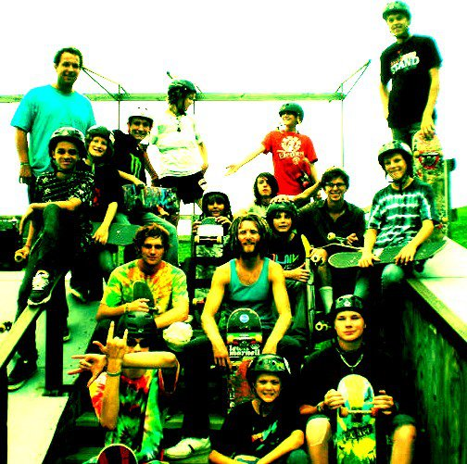
The draw of Jamaica soon returned, and he flew back to the island for another six-month stay. This trip, however, his time was allotted to farming up in the remote hills of St. Thomas. Lack of funds prevented further studio work, and the allure of opportunities to pursue music in Jamaica remained unobtainable. It seemed as if his musical dreams were not a likely reality.

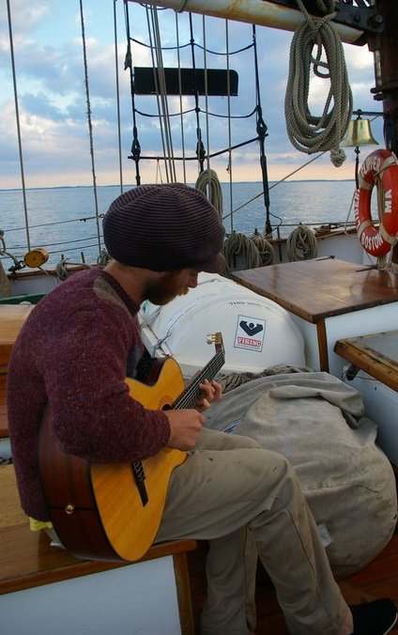
The next few years were a mix of traveling between the United States and Jamaica, working as a deckhand aboard tall ships, taking positions as a camp counselor at a skateboard camp in Maryland, and finding temporary jobs on several organic farms. Writing songs along the way, his dream of musical pursuits was still alive, but he still needed time to obtain the means to launch his career.

In 2011, Jeremiah traveled to Miami to visit a childhood friend who was working at a local recording studio. Out of funds and with no seasonal jobs on the horizon, he began washing cars with a fellow church member in Liberty City and soon found a position at a local Publix supermarket. He recorded partial tracks at the recording studio in his spare time, but his friend soon moved out to LA and his hopes of doing some quality recording soon dissolved.

After almost 5 years as a part-time supermarket stock clerk, Jeremiah received a loan from some members of his local church in order to take the Florida state test to obtain a teaching license. After passing the required exams, he spent a year and a half as a high school English teacher for the Miami-Dade County public schools, working with students from all over the world including the Caribbean, South America, and Russia.
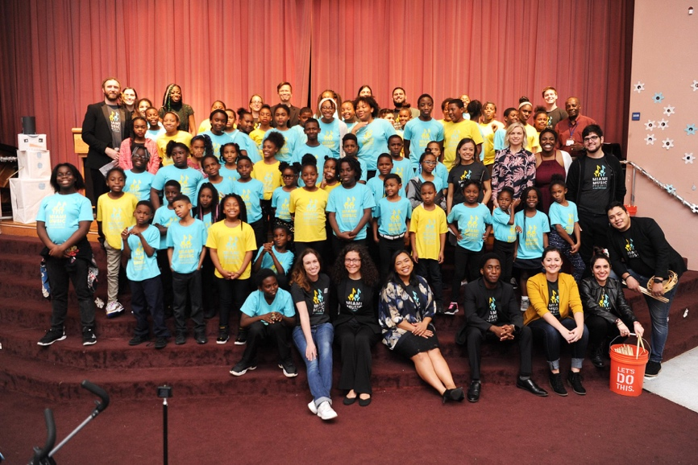
Overwhelmed by the demand of the position, he knew that he needed to find his way back into the world of music. He soon found a position at a local non-profit, the Miami Music Project, where he was hired on as the Site Director for the Liberty City chapter. He was soon overseeing an after-school program designed to teach students from the urban core who had dreams of becoming musicians and playing in orchestras.

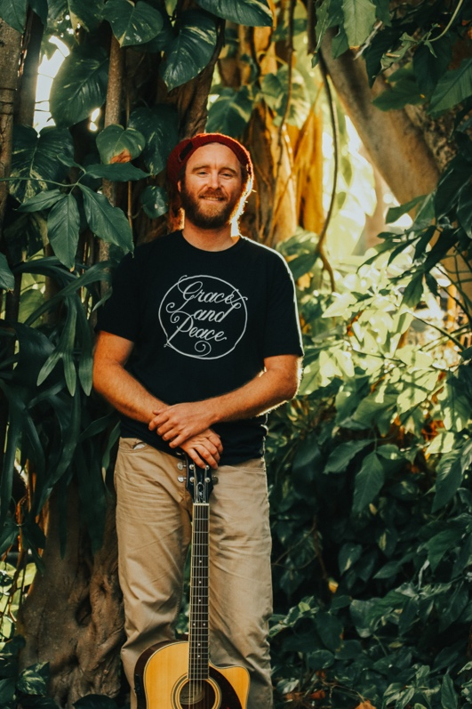
It was not long after this turn of events that Jeremiah decided to enter into the Music Business graduate program at the University of Miami. Working with professors who had significant industry experience, Jeremiah was able to wed his musical background with industry standards in order to launch his career as an independent artist. This was the footing he needed to begin his music campaign.

Collaborating with Teaching Artists from the Miami Music Project and fellow musicians from his local congregation, Miami Bible Church, Jeremiah now seeks to exhibit the truth and light of the Scriptures for his audience through the joy of music as he combines years of experience and longstanding musical efforts that he brings to the table. As he serves the community of Liberty City and encourages children in their musical development, he writes and arranges original acoustic reggae music combined with a variety of classical chamber ensemble accompaniments. The sound is a natural outflow of the adventurous life he has lived and an expression of the Christian faith he holds dear.

